Q1

CREATE TABLE MOVIES (

movieid INT PRIMARY KEY,

title VARCHAR(35) NOT NULL,

releaseYear INT NOT NULL,

director INT NOT NULL,

score DECIMAL(3, 2) CHECK (score > 3 AND score < 10)

);

CREATE TABLE ACTORS (

actorid INT PRIMARY KEY,

firstName VARCHAR(20) NOT NULL,

lastName VARCHAR(30) NOT NULL

);

CREATE TABLE CASTINGS (

movieid INT,

actorid INT,

PRIMARY KEY (movieid, actorid),

FOREIGN KEY (movieid) REFERENCES MOVIES(movieid),

FOREIGN KEY (actorid) REFERENCES ACTORS(actorid)

CREATE TABLE DIRECTORS (

directorid INT PRIMARY KEY,

firstname varchar(20) NOT NULL,

lastname varchar(30) NOT NULL

Q2

ALTER TABLE MOVIES

ADD CONSTRAINT fk_director

FOREIGN KEY (director)

REFERENCES directors(directorid);

Q3

ALTER TABLE MOVIES

Q4

INSERT ALL

INTO DIRECTORS (directorid, firstname, lastname) VALUES (1010, 'Rob', 'Minkoff')

INTO DIRECTORS (directorid, firstname, lastname) VALUES (1020, 'Bill', 'Condon')

INTO DIRECTORS (directorid, firstname, lastname) VALUES (1050, 'Josh', 'Cooley')

INTO DIRECTORS (directorid, firstname, lastname) VALUES (2010, 'Brad', 'Bird')

INTO DIRECTORS (directorid, firstname, lastname) VALUES (3020, 'Lake', 'Bell')

SELECT * FROM DUAL;

INSERT ALL

INTO MOVIES (MOVIEID, TITLE, RELEASEYEAR, DIRECTOR, SCORE) VALUES (100, 'The Lion King', 2019, 3020, 3.50)

INTO MOVIES (MOVIEID, TITLE, RELEASEYEAR, DIRECTOR, SCORE) VALUES (200, 'Beauty and the Beast', 2017, 1050, 4.20)

INTO MOVIES (MOVIEID, TITLE, RELEASEYEAR, DIRECTOR, SCORE) VALUES (300, 'Toy Story 4', 2019, 1020, 4.50)

INTO MOVIES (MOVIEID, TITLE, RELEASEYEAR, DIRECTOR, SCORE) VALUES (400, 'Mission Impossible', 2018, 2010, 5.00)

INTO MOVIES (MOVIEID, TITLE, RELEASEYEAR, DIRECTOR, SCORE) VALUES (500, 'The Secret Life of Pets', 2016, 1010, 3.90)

SELECT * FROM DUAL;

Q5

DROP TABLE MOVIES;

When removing tables without any dependencies, the order doesn't matter. However, if there are dependencies like foreign key constraints, you need to drop the dependent tables first before dropping the referenced tables to avoid any constraint violations and errors.

Q6

CREATE TABLE employeecopy AS

SELECT *

FROM RETAILEMPLOYEES

WHERE 1=2;

Q7

ALTER TABLE employeecopy

ADD username VARCHAR(50) NULL;

Q8

INSERT INTO EMPLOYEECOPY (EMPLOYEENUMBER, LASTNAME, FIRSTNAME, EXTENSION, EMAIL, OFFICECODE, REPORTSTO, JOBTITLE, USERNAME)

SELECT EMPLOYEENUMBER, LASTNAME, FIRSTNAME, EXTENSION, EMAIL, OFFICECODE, REPORTSTO, JOBTITLE, NULL

FROM RETAILEMPLOYEES;

Q9

UPDATE EMPLOYEECOPY

SET USERNAME = CONCAT(EMPLOYEENUMBER, '@seneca.ca');

Q10

DELETE FROM employeecopy;

SELECT * FROM EMPLOYEECOPY

Q11

INSERT INTO RETAILEMPLOYEES (EMPLOYEENUMBER, LASTNAME, FIRSTNAME, EXTENSION, EMAIL, OFFICECODE, REPORTSTO, JOBTITLE)

VALUES (1234, 'Gyeongrok', 'Oh', 'x1234', 'goh3@seneca.ca', 4, 1088, 'Cashier');

Q12

SELECT *

FROM RETAILEMPLOYEES

WHERE EMPLOYEENUMBER = 1234;

Q13

UPDATE RETAILEMPLOYEES

SET JOBTITLE = 'Head Cashier'

WHERE EMPLOYEENUMBER = 1234;

Q14

INSERT INTO RETAILEMPLOYEES (EMPLOYEENUMBER, LASTNAME, FIRSTNAME, EXTENSION, EMAIL, OFFICECODE, REPORTSTO, JOBTITLE)

Q15

DELETE FROM RETAILEMPLOYEES

WHERE EMPLOYEENUMBER = 1234;

to delete a row from the "RETAILEMPLOYEES" table where the "EMPLOYEENUMBER" is 1234. However, the deletion is not allowed because it would violate the foreign key constraint named "EMP_RTEMP_FK." This constraint signifies that there are child records in another table referencing specific rows in the "RETAILEMPLOYEES" table.

Q16

DELETE FROM RETAILEMPLOYEES

WHERE EMPLOYEENUMBER = 9876;

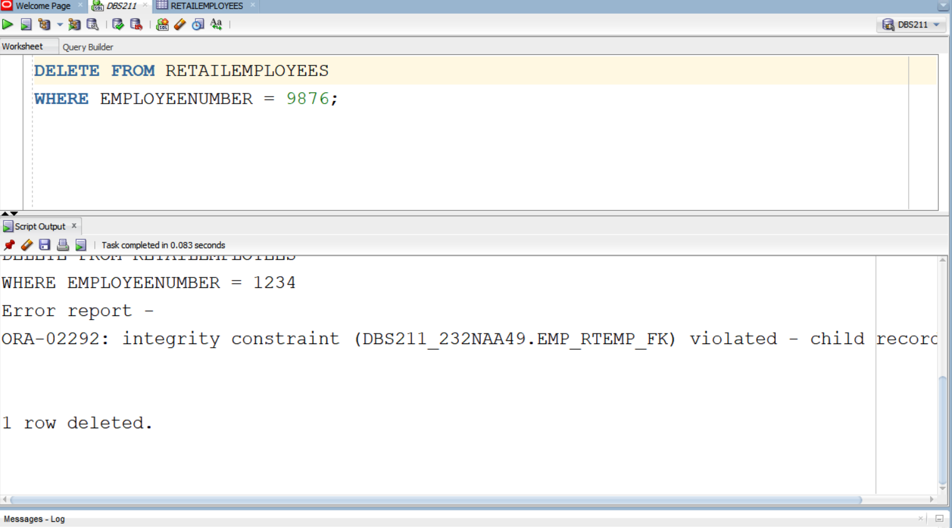

DELETE FROM RETAILEMPLOYEES

WHERE EMPLOYEENUMBER = 1234;

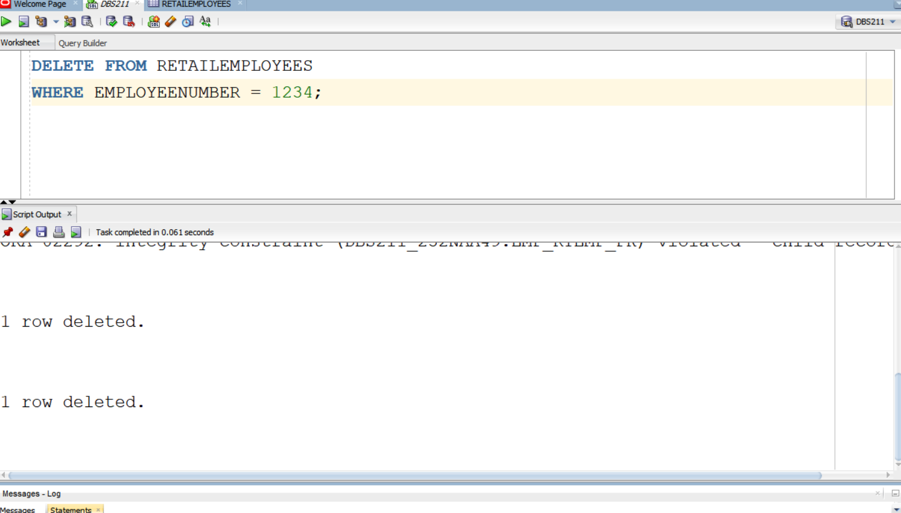

Q17

INSERT ALL

INTO RETAILEMPLOYEES VALUES (9876, 'Smith', 'John', 'x9876', 'john.smith@example.com', 4, 1088, 'Cashier')

INTO RETAILEMPLOYEES VALUES (1234, 'Gyeongrok', 'Oh', 'x1234', 'goh3@seneca.ca', 4, 1088, 'Head Cashier')

SELECT* FROM DUAL

Q18

DELETE FROM RETAILEMPLOYEES

Q19

INSERT INTO RETAILORDERS (ORDERNUMBER, ORDERDATE, REQUIREDDATE, SHIPPEDDATE, STATUS, COMMENTS, CUSTOMERNUMBER)

Q20

INSERT INTO RETAILPRODUCTS (PRODUCTCODE, PRODUCTNAME, PRODUCTLINE, RETAILPRODUCTSCALE, PRODUCTVENDOR, PRODUCTDESCRIPTION, QUANTITYINSTOCK, BUYPRICE, MSRP)

VALUES ('S111_111', '2020 Bugatti Veyron', 'Classic Cars', '1:12', 'Exquisite Cars', 'A stunning model of the iconic 2020 Bugatti Veyron.', 6800, 299.99, 599.99);

